1. Information and Communication Technology (ICT)

Introduction to ICT and Literacy

Information and Communication Technology (ICT) is an umbrella term that covers all technological tools and resources used to create, store, manage, communicate, disseminate, and share information. These include computer systems, the internet, broadcasting technologies (radio and TV), and telephony (mobile/landlines).

Components of ICT
The core components of an ICT system generally include:
- Hardware: The physical devices and equipment (e.g., computers, servers, routers, keyboards, mobile phones).
- Software: The programs and applications that run on the hardware (e.g., Operating Systems, word processors, browsers).
- Data: The raw facts and figures that are collected, stored, and processed.
- Network: The systems that connect computers and devices to allow communication (e.g., LAN, Wi-Fi, the Internet).
- People: The users, developers, and administrators who operate and manage the technology.⁹

Scope of ICT

ICT has permeated nearly every aspect of modern life:
Sector | Scope of ICT Application
Education | - E-learning  - virtual classrooms  - digital libraries  - online student enrollment  - educational software  - (e.g., learning management systems).
Health | - Telemedicine (remote consultations)  - Electronic Health Records (EHRs)  - remote patient monitoring  - medical imaging systems.
Business | - E-commerce  - Customer Relationship  - Management (CRM)  - Enterprise Resource Planning (ERP)  - digital marketing  - online payment systems.
Finance | - Online banking  - Automated Teller Machines(ATMs)  - mobile money transfers  - algorithmic trading  - financial data analysis.
Government Use | - E-governance  - (online tax filing, digital public services),  - national ID systems  - digital census  - public data management.
Entertainment | - Streaming services (video/music)  - online gaming  - social media  - content creation  - digital media editing.
Manufacturing | - Computer-Aided Design (CAD)  - Manufacturing (CAM)  - robotics and automation  - Supply Chain Management (SCM)  - Internet of Things (IoT) in factories.

Advantages and Disadvantages of ICT

Advantages | Disadvantages
- Global Access: Instant access to a vast network of information and resources. | - Digital Divide: Unequal access to ICT between different regions or socioeconomic groups.
- Efficiency & Speed: Automates tasks, speeds up communication, and improves process efficiency in all sectors. | - Security Threats: Increased risk of cyberattacks, hacking, viruses, and data breaches.
- Better Communication: Enables instant and rich communication across the globe (email, video conferencing). | - Job Displacement: Automation via ICT can lead to unemployment in certain manual or routine fields.
- Innovation: Drives rapid development in science, medicine, and business. | - Information Overload: Difficulty in sifting through the vast amount of available data (slowing decision-making).

Ethical Considerations and Skill Gap

- Ethical Considerations:
- Privacy and Data Protection: Concerns over the collection, storage, and unauthorized use of personal data.
- Intellectual Property Rights: Issues of copyright, piracy, and ownership of digital content and software.

- Netiquette and Digital Citizenship: Appropriate and responsible behavior in the
online world.
- Accountability: Determining responsibility when automated or AI systems cause harm or error.
- Skill Gap: This refers to the difference between the ICT skills required for modern jobs and the skills possessed by the workforce. Addressing this gap is critical for economic growth and competitiveness.

Applying ICT for the Future
The future of ICT involves convergence with emerging technologies such as Artificial Intelligence (AI), Internet of Things (IoT), Big Data, and Cloud Computing. This will lead to smarter cities, hyper-personalized services, highly automated industries, and a greater need for robust cybersecurity and ethical governance.

2. Computer Fundamentals

What is a Computer and How It Works?

A computer is an advanced electronic device that accepts raw data (input), processes it according to a set of pre-stored instructions (program), produces useful information (output), and stores the results for future use.
The fundamental working process is known as the Input-Process-Output (IPO) Cycle:
- Input: Data is entered into the computer via input devices (e.g., keyboard, mouse).
- Processing: The Central Processing Unit (CPU) executes instructions to transform the raw data into meaningful information.
- Output: The processed information is presented to the user via output devices (e.g., monitor, printer).
- Storage: The data and information are saved in memory for later access.

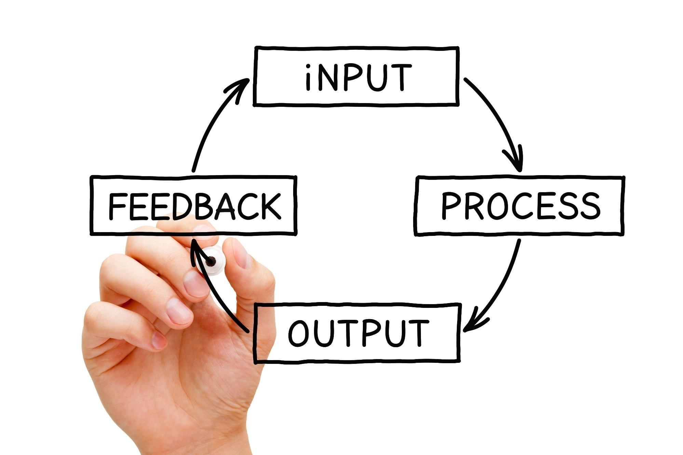
Shutterstock

Hardware in Detail
Hardware refers to the physical, tangible components of a computer system.¹⁸

Category | Description and Examples
Input Devices | Used to enter data and instructions (e.g., Keyboard, Mouse, Scanner, Microphone, Webcam).
Processing Devices | The "brain" that executes instructions. Central Processing Unit (CPU) is the main one.  - It contains the Arithmetic Logic  Unit (ALU) for calculations.  - The Control Unit (CU) for managing operations.
Memory/Storage | Stores data and programs.
* Primary Memory (Volatile): RAM
(Random Access Memory) holds data
and programs currently in use. Data is lost when power is off.
* Secondary Storage (Non-Volatile):
Stores data permanently (e.g., Hard Disk Drive (HDD), Solid State Drive (SSD), USB Flash Drive).
Output Devices | Used to display or communicate the processed information (e.g., Monitor, Printer, Speaker).
Motherboard | The main circuit board that connects all other hardware components.

Software and Its Types

Software is a set of instructions, data, or programs used to operate computers and execute specific tasks. It is the intangible component.

Types of Software

- System Software: Manages and controls the hardware components and enables application software to run.

  - Operating System (OS): The core software that manages all hardware and software resources (e.g., Windows, macOS, Linux, Android).

○ Utility Programs: Helps to manage, maintain, and control computer resources (e.g., antivirus, file managers, disk cleanup).

○ Device Drivers: Translates OS instructions into a format the hardware can understand.

- Application Software: Performs specific tasks for the user.

  - General Purpose: Used for common tasks (e.g., Microsoft Word, Adobe Photoshop, Web Browsers).
○ Specific Purpose (Custom): Designed for a unique task or organization (e.g., hospital management system, flight control software).

Operating System (OS) and Its Features

An Operating System is the most crucial system software. It acts as an interface between the user and the computer hardware.
● Key Features:
○ Memory Management: Manages and allocates memory to different running programs.
○ Process Management: Manages the running of multiple programs (processes).
○ File Management: Organizes and stores data in a structured manner (directories/folders).
○ Device Management: Controls all hardware devices via drivers.
○ User Interface (UI): Provides a way for the user to interact with the computer (e.g., Graphical User Interface - GUI).
Type of Computer: Personal Computer (PC)

A Personal Computer (PC) is a microcomputer designed for general use by a single person. It is characterized by its size, capability, and price, making it accessible for individuals.
● Examples: Desktop computers, laptops, and tablets.

Characteristics of a Computer

Computers are defined by their outstanding capabilities:
- Speed: Computers can perform millions of instructions per second, measured in milliseconds, microseconds, or nanoseconds.
- Accuracy: Their calculations are virtually 100% error-free, provided the input data is correct (GIGO - Garbage In, Garbage Out).
- Diligence: Computers can work continuously for long periods without getting tired or losing concentration.
- Storage Capability: They can store and retrieve massive amounts of data and programs permanently.
- Versatility: They are flexible and can perform a wide range of tasks, from complex scientific problems to simple games.

Data
Data is a collection of raw facts, figures, and symbols that, when unprocessed, have no specific meaning or context.
- Examples: The number '101', the text 'apple', the date '2025-11-07'.
- Data Types (Common in programming/systems):
○ Numeric: Integers (whole numbers) and floating-point (decimal numbers).
○ Alphanumeric/String: Text, including letters, numbers, and symbols.
○ Boolean: Logical data, typically represented as True or False.
○ Date/Time: Represents specific moments in time.

Information
Information is processed, organized, structured, or presented data that provides context and meaning.³² It is useful for human understanding and decision-making.³³
● Example: Converting the raw data ('101', 'apple', '2025-11-07') into: "Inventory Report: On 2025-11-07, we sold 101 bags of apples."

Data vs. Information

Feature | Data | Information
Nature | Raw facts and figures. | Processed, organized data.
Meaning | No specific meaning on its own. | Has meaning and context.
Dependence | Does not depend on information. | Dependent on data.
Decision | Insufficient for decision-making. | Sufficient for decision-making.

Websites vs. Search Engines

Feature | Website | Search Engine
Definition | A collection of related web pages, images, videos, etc., hosted on a web server, accessible via a single domain name. | A software system designed to search for information on the World Wide Web.
Function | To provide content and services (e.g., e-commerce, news, social media). | To index the web and retrieve relevant links in response to a user's query.
Example | Wikipedia, Amazon, your school's official page. | Google, Bing, DuckDuckGo.
Importance of Websites: Websites are the fundamental building blocks of the Internet, serving as digital platforms for communication, commerce, information, and entertainment.
Website Basics: A website is accessed via a URL (Uniform Resource Locator). It is built using programming languages like HTML (structure), CSS (style), and JavaScript (interactivity).

How Search Engines Operate in Detail
Search engines operate through three primary stages: Crawling, Indexing, and Ranking.³⁵
- Crawling (Discovery):
  - Specialized automated programs called web crawlers (or bots/spiders) travel across the Internet, following links from one page to another.
○ They discover new and updated web pages.
○ The crawler downloads the page's content, including text, images, and other files.

- Indexing (Organization):
  - The search engine analyzes the downloaded content to understand what the page is about (e.g., keywords, topics, language).
○ This information is then stored in a massive, structured database called the Index (similar to a library catalog).
○ When you search, the engine looks up your keywords in this index, not on the live web.

- Ranking (Serving Results):
  - When a user enters a search query, the search engine's algorithm quickly searches the index for matching pages.
○ It then scores and orders these results based on hundreds of factors (e.g., relevance, quality of content, authority of the website, user's location, device).
○ The highly-ranked results are presented to the user on the Search Engine Results Page (SERP).

4. Tools (Word Processor)

A Word Processor is an application software used for the creation, editing, formatting, and printing of text-based documents. It is one of the most common productivity tools.

- Tool Example: Microsoft Word, Google Docs, OpenOffice Writer.

- Core Functions (Tools):
○ Text Manipulation: Inserting, deleting, cutting, copying, and pasting text.

○ Formatting: Changing font styles, sizes, colors, and paragraph alignment.
○ Document Structure: Creating tables, lists (numbered/bulleted), headers, and footers.
○ Reviewing: Spell check, grammar check, and thesaurus.
○ Layout: Setting margins, page size, and orientation.

